Project Design Phase-II
Data Flow Diagram & User Stories
Date | 17 June 2026
Team ID | Individual
Project Name | ShopEZ – E-Commerce Application
Maximum Marks | 4 Marks

Data Flow Diagram (Level-0)
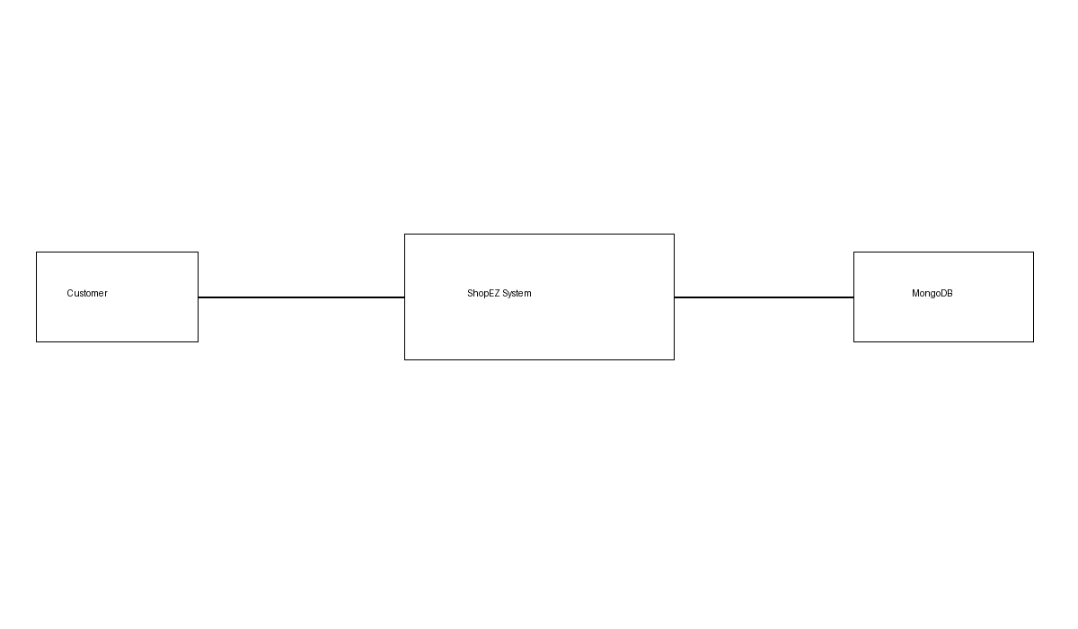
Customer interacts with ShopEZ system to browse products, manage cart and place orders. The system stores and retrieves data from MongoDB database.

User Stories
User Type | Epic | User Story No | User Story / Task | Acceptance Criteria | Priority | Release
Customer | Registration | USN-1 | Register account using email and password | Account created successfully | High | Sprint-1
Customer | Login | USN-2 | Login with valid credentials | Dashboard opens | High | Sprint-1
Customer | Products | USN-3 | Browse products | Products displayed | High | Sprint-1
Customer | Cart | USN-4 | Add products to cart | Cart updated | High | Sprint-1
Customer | Orders | USN-5 | Place order | Order created | High | Sprint-1
Customer | Orders | USN-6 | View order history | Orders visible | Medium | Sprint-2
Admin | Product Management | USN-7 | Add products | Product stored | High | Sprint-1
Admin | Product Management | USN-8 | Edit products | Changes saved | High | Sprint-1
Admin | Product Management | USN-9 | Delete products | Product removed | Medium | Sprint-2
Admin | Order Management | USN-10 | Manage orders | Status updated | High | Sprint-2

